## **Assignment 06: Assignment and Practice of Prompt Engineering**

## **Task 1: Prompt Categorization**

### **Prompt 1:**

**'Generate a logo for a tech startup using neon colors.'**

* **Type:** **Visual Prompt**
* **Reasoning:** This prompt is directing an AI model (like DALL·E or a graphic generation tool) to create a **visual output** (a logo). It specifies design elements (neon colors) and context (tech startup).

### **Prompt 2:**

**'Explain blockchain to a 5-year-old.'**

* **Type:** **Conversational Prompt**
* **Reasoning:** The prompt is phrased as a **question** and asks the model to explain a concept in simple terms, suitable for a child. It's conversational and instructional in nature, aiming for clarity and simplification.

### **Prompt 3:**

**'You are a UX designer. Suggest improvements to this app layout.'**

* **Type:** **Role-based Prompt**
* **Also fits under:** **Instructional Prompt**
* **Reasoning:** The prompt uses **role-based framing** ("You are a UX designer") and gives a clear instruction ("Suggest improvements..."). This helps the AI adopt a specific point of view or expertise to respond appropriately.

### **Final Categorization Table:**

| **Prompt** | **Type** | **Reason** |
| --- | --- | --- |
| **Generate a logo for a tech startup using neon colors.** | Visual | Instructs image generation using design-specific elements |
| **Explain blockchain to a 5-year-old.** | Conversational | Asks for a simplified, child-friendly explanation |
| **You are a UX designer. Suggest improvements to this app layout.** | Role-based / Instructional | Assigns a role and asks for professional input |

## **Task 2: Refinement Practice**

| **Original Prompt** | **Refined Prompt** | **Reason for Refinement** |
| --- | --- | --- |
| **1. Draw something cool.** | **Create a digital illustration of a futuristic city at night, with flying cars and neon lights in a cyberpunk style.** | Added visual style, setting, and theme for more focused output. |
| **2. Write a story.** | **Write a 300-word short story about a young girl who discovers a hidden portal in her school library that leads to an underwater city.** | Defined word count, characters, setting, and plot direction. |
| **3. Make a video.** | **Generate a 30-second promotional video script for a new fitness app targeting college students, focusing on daily motivation and progress tracking.** | Specified purpose, audience, length, and key themes. |
| **4. Explain climate change.** | **Explain climate change to middle school students using simple language, relatable examples, and a positive tone.** | Defined audience and tone to control complexity and approach. |
| **5. Design a logo.** | **Design a minimalist logo for a vegan café named “Green Spoon,” using green and beige colors and a plant-based symbol.** | Provided brand name, style, color scheme, and theme. |
| **6. Help me study.** | **Act as a study coach and create a 1-week revision plan for a high school student preparing for a math exam, including daily topics and practice tips.** | Assigned a role to the AI, defined time frame, subject, and output format. |

## **Task 3: Design 5 original prompts for different domains**

### **1. Prompt for ChatGPT (Text-Based, Creative Writing Domain)**

**Prompt:** *“Write a dual-perspective short story in the mystery genre. The story should alternate between the thoughts of a detective investigating a decades-old cold case and the diary entries of the original suspect, who has since disappeared. Build suspense gradually and reveal a major twist in the final paragraph that challenges the reader’s assumptions.”*

### **2. Prompt for DALL·E (Image-Based, Concept Art Domain)**

**Prompt:** *“Create a concept art illustration of a futuristic floating marketplace in the sky, held up by massive balloons and drones. The scene should include a variety of stalls selling alien goods, diverse alien species interacting, and a glowing sunset behind the clouds. Style: vibrant, detailed, and slightly surreal.”*

### **3. Prompt for SORA/Vevo (gemini) (Video-Based, Storytelling/Cinematic Domain)**

**Prompt:** *“Generate a short cinematic video of a post-apocalyptic city slowly being reclaimed by nature. Show ivy crawling over abandoned skyscrapers, wild animals roaming empty streets, and a sunrise breaking through the ruins. The tone should be melancholic yet hopeful, with slow, ambient background music.”*

### **4. Prompt for Coding or Logic (Problem Solving Domain)**

**Prompt:** *“Write a Python function that takes a list of strings and returns the longest possible palindrome that can be made by rearranging the letters from all the strings combined. If no palindrome is possible, return an empty string. Include test cases and explain the logic behind your approach.”*

### **5. Prompt for Education or Training (Corporate Training Domain)**

**Prompt:** *“Design a 20-minute microlearning module outline for new managers on the topic of ‘Giving Constructive Feedback’. The module should include: learning objectives, interactive elements (quizzes, scenarios), a short video script idea, and a follow-up assessment question. Emphasize psychological safety and real-world application.”*

Practice Activity (Live Testing)

1)ChatGPT (for text or logic)

**Prompt:** *“Write a dual-perspective short story in the mystery genre. The story should alternate between the thoughts of a detective investigating a decades-old cold case and the diary entries of the original suspect, who has since disappeared. Build suspense gradually and reveal a major twist in the final paragraph that challenges the reader’s assumptions.”*

**Answer from Chat-gpt:**

**Title: *The Briar Hollow Disappearance***

### **Detective's Log – March 12, 2025**

**33 years ago, Margaret Lane vanished in Briar Hollow. Blood on a tree. No body. One suspect: Elias Crane, 17, vanished days later.**

**Today, I reopened the case. His diary was still in the evidence box.**

### **Elias’s Diary – August 3, 1992**

**Margaret loves the forest. We found an old stone circle. She stepped in and said, “It feels like it’s waiting.”**

**Waiting for what?**

### **Detective's Log – March 13, 2025**

**Found the stone circle. Still there. Silent.**

**In the center, buried: a cracked mirror with “M.L.” scratched on the back.**

### **Elias’s Diary – August 10, 1992**

**She said the forest made her an offer. Someone had to stay.**

**She kissed me and whispered, “Don’t worry. You won’t even remember.”**

### **Unknown Entry – August 12, 1992**

**I woke up alone in the woods. Wearing Elias’s clothes. But I don’t think I’m him.**

**Who am I?**

### **Detective's Log – March 14, 2025**

**The diary’s last entry… it’s in my handwriting.**

**I checked my reflection. It hesitated.**

**I checked my ID. Name: *Detective Raymond Hale*—but another name is written faintly underneath: *Elias Crane*.**

**Final Line:  
 I never remembered my life before 18.**

**And somewhere, Margaret Lane is still out there—smiling.**

**2) DALL·E (for image generation)**

**Prompt:** *“Create a concept art illustration of a futuristic floating marketplace in the sky, held up by massive balloons and drones. The scene should include a variety of stalls selling alien goods, diverse alien species interacting, and a glowing sunset behind the clouds. Style: vibrant, detailed, and slightly surreal.”*

**Image from DALL-E:**

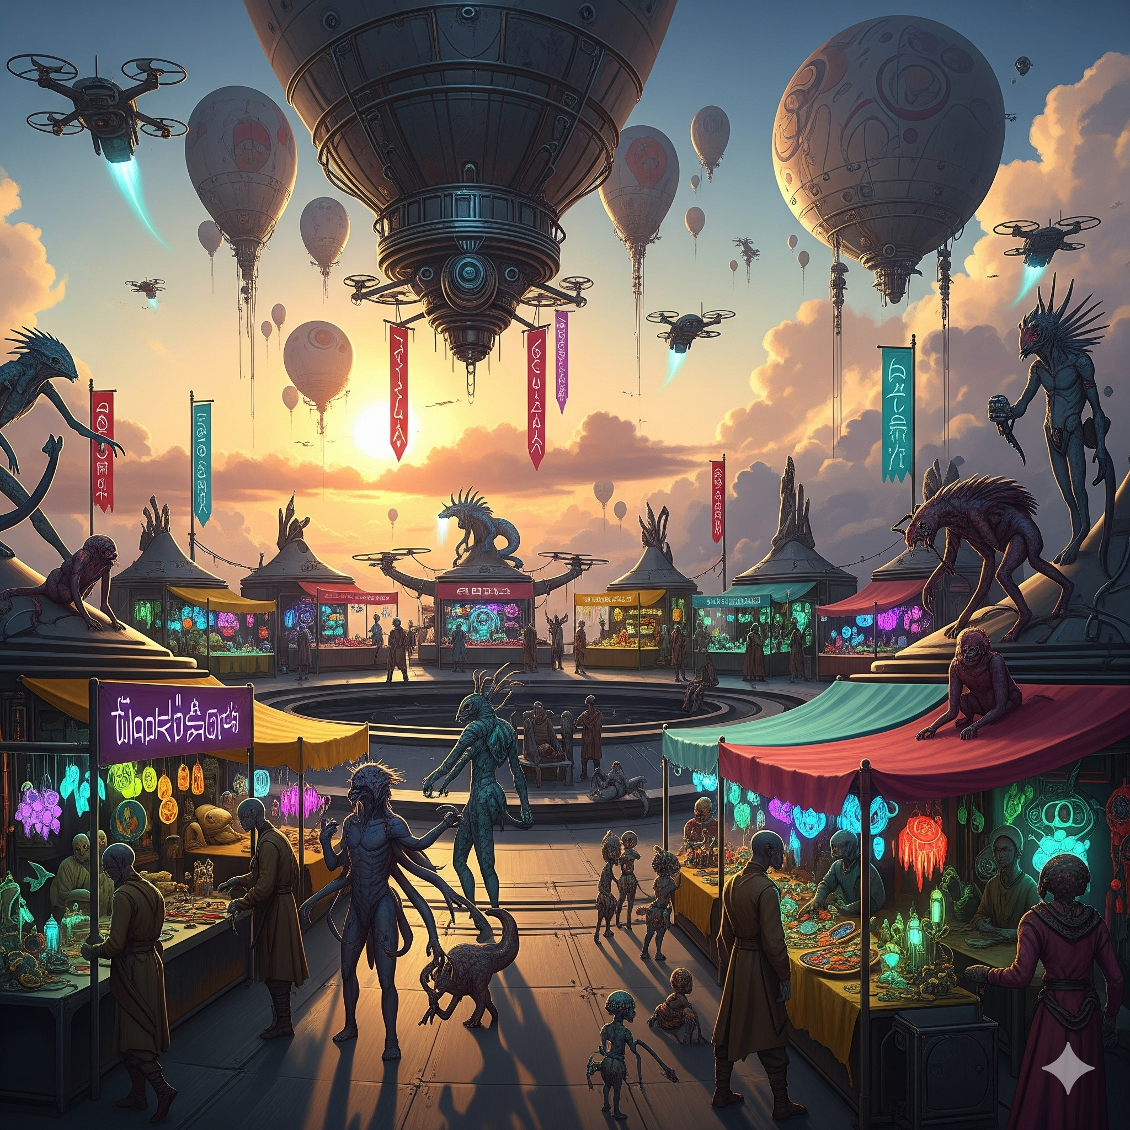

### 

### **3. Prompt for SORA/Vevo (gemini) (Video-Based, Storytelling/Cinematic Domain)**

**Prompt:** *“Generate a short cinematic video of a post-apocalyptic city slowly being reclaimed by nature. Show ivy crawling over abandoned skyscrapers, wild animals roaming empty streets, and a sunrise breaking through the ruins. The tone should be melancholic yet hopeful, with slow, ambient background music.”*

**Video From Gemini:**[**Output Video**](https://drive.google.com/file/d/1Xv-tRokzkQFCVjCas8SBMZoc1AplueP0/view?usp=sharing)

### **4. Prompt for Coding or Logic (Problem Solving Domain)**

**Prompt:** *“Write a Python function that takes a list of strings and returns the longest possible palindrome that can be made by rearranging the letters from all the strings combined. If no palindrome is possible, return an empty string. Include test cases and explain the logic behind your approach.”*

**Answer from chat-gpt**

## **Problem: Longest Possible Palindrome from List of Strings**

### **Prompt**

**Write a Python function that takes a list of strings and returns the longest possible palindrome that can be made by rearranging the letters from all the strings combined.  
 If no palindrome is possible, return an empty string.**

## **Logic & Explanation**

**To form a valid palindrome:**

* **Characters should occur in pairs (i.e., even number of times) so they can be mirrored on both sides.**
* **At most one character can occur an odd number of times (which becomes the center of the palindrome).**

### **Steps:**

1. **Combine all characters from all strings into a single string.**
2. **Count the frequency of each character using collections.Counter.**
3. **For each character:**
   * **Use as many pairs as possible to build the two halves.**
   * **If the character occurs odd times and no center character has been chosen yet, select it as the center.**

**Build the final palindrome as:  
  
 [left_half] + [center_char] + [reverse(left_half)]**

## **Python Code Implementation**

**from collections import Counter**

**def longest_palindrome_from_strings(strings):**

**# Step 1: Combine all strings into one string**

**all_chars = ''.join(strings)**

**# Step 2: Count frequencies of each character**

**freq = Counter(all_chars)**

**# Prepare components for the palindrome**

**left_half = []**

**center_char = ''**

**# Step 3: Build the palindrome parts**

**for char, count in freq.items():**

**# Use as many full pairs as possible**

**pairs = count // 2**

**if pairs > 0:**

**left_half.append(char * pairs)**

**# Choose one odd-count character as the center**

**if count % 2 == 1 and not center_char:**

**center_char = char**

**# Step 4: Assemble the palindrome**

**left = ''.join(sorted(left_half)) # Sort for deterministic output**

**right = left[::-1] # Mirror the left half**

**palindrome = left + center_char + right**

**# Step 5: Return the result**

**return palindrome if any(freq.values()) else ''**

## **Test Cases**

**def test_longest_palindrome():**

**print("Test 1:", longest_palindrome_from_strings(["abc", "cba"])) # abccba**

**print("Test 2:", longest_palindrome_from_strings(["a", "b", "c"])) # a (or b/c)**

**print("Test 3:", longest_palindrome_from_strings(["aa", "bb", "cc"])) # abccba**

**print("Test 4:", longest_palindrome_from_strings(["abc", "def"])) # (no pairs) ''**

**print("Test 5:", longest_palindrome_from_strings(["aaa", "bbb", "c"])) # aabbaa or babab**

**print("Test 6:", longest_palindrome_from_strings([""])) # ''**

**print("Test 7:", longest_palindrome_from_strings([])) # ''**

**print("Test 8:", longest_palindrome_from_strings(["race", "car"])) # racecar**

**# Run the tests**

**test_longest_palindrome()**

## **Sample Output:**

**Test 1: abccba**

**Test 2: a**

**Test 3: abccba**

**Test 4:**

**Test 5: aabbaa**

**Test 6:**

**Test 7:**

**Test 8: racecar**

**Note: In tests with multiple possible answers (like Test 5), the output might vary in structure but still be a valid longest palindrome.**

### 

### 

### 

### 

### **5. Prompt for Education or Training (Corporate Training Domain)**

**Prompt:** *“Design a 20-minute microlearning module outline for new managers on the topic of ‘Giving Constructive Feedback’. The module should include: learning objectives, interactive elements (quizzes, scenarios), a short video script idea, and a follow-up assessment question. Emphasize psychological safety and real-world application.”*

**Answer From Chat-Gpt:**

## **Microlearning Module: Giving Constructive Feedback**

### **Duration: 20 minutes**

### **Target Audience: New Managers / Team Leads**

### **Learning Objectives (By the end of this module, learners will be able to):**

1. **Define what constructive feedback is and why it matters.**
2. **Apply a simple framework (e.g., SBI: Situation–Behavior–Impact) to structure feedback clearly.**
3. **Deliver feedback in a way that maintains psychological safety and trust.**
4. **Recognize and correct common mistakes when giving feedback.**

### **Module Breakdown**

**1. Introduction & Hook (2 minutes)**

* **Format: Animated video or voiceover slideshow**
* **Content:**
  + **A relatable workplace scenario: A team member submits work late, again.**
  + **Pose a question: “How would you handle this conversation?”**
* **Purpose: Create relevance and curiosity.**

**2. Core Content & Framework (6 minutes)**

* **Format: Interactive Slide + Short Video**
* **Topics Covered:**
  + **What is constructive feedback?**
    - **Focus on improvement, not criticism.**
    - **Delivered with empathy and purpose.**
  + **Psychological Safety Defined:**
    - **Making it safe for people to speak up, receive input, and grow.**
  + **SBI Model (Situation–Behavior–Impact):**
    - **Example: “In yesterday’s meeting (Situation), you interrupted Sarah (Behavior), which made it hard for her to contribute (Impact).”**
* **Interactive Element:**
  + **Quick Drag-and-Drop Activity: Match examples to the correct part of the SBI model.**

**3. Scenario-Based Practice (6 minutes)**

* **Format: Interactive Scenario Simulation**
* **Instructions:  
   Learners choose from multiple responses in realistic workplace feedback scenarios. Each choice results in different outcomes and reactions.**
* **Example Scenario:**
  + **You notice your team member, Alex, seems disengaged during meetings.**
  + **Learner selects how to address it:**
    - **A: “You’re clearly not paying attention—what’s going on?”**
    - **B: “I noticed you seemed distracted in the last few meetings. Is everything okay?”**
    - **C: Ignore it for now.**
* **Feedback:  
   Explain why B is best: it addresses behavior with concern and opens dialogue.**

**4. Video Script Idea (3 minutes)  
 Title: “What Feedback Sounds Like When It’s Done Right”**

* **Scene 1: Manager giving vague or negative feedback—employee reacts defensively.**
* **Scene 2: Same scenario using the SBI model and a calm tone—employee opens up.**
* **Key Message (Narrator):  
   “It’s not just what you say—it’s how and when you say it. Constructive feedback isn’t confrontation—it’s collaboration.”**
* **Tone: Supportive, realistic, and empowering.**

**5. Knowledge Check / Assessment (2 minutes)**

* **Format: Multiple-Choice Question**
* **Question:  
   Which of the following best demonstrates constructive feedback while preserving psychological safety?  
    
   A. “You never speak up in meetings—you should be more assertive.”  
   B. “Last week in the client meeting, I noticed you were quiet. I value your input—what’s your take on that?”  
   C. “You’re just not leadership material if you don’t speak up.”**
* **Correct Answer: B**
* **Explanation: This uses specific observation, expresses value, and opens dialogue.**

**6. Final Takeaway & Downloadable Tip Sheet (1 minute)**

* **Provide a one-page PDF download including:**
  + **Top 5 Tips for Constructive Feedback**
  + **SBI model summary**
  + **Phrases to avoid / Phrases to use**
  + **Reminder to prioritize psychological safety**